1. **Download Unity 2019.x or higher** <https://store.unity.com/download>
2. **Download Git** <https://git-scm.com/downloads>
3. **Download Sidequest** <https://sidequestvr.com/setup-howto>
4. **Download and install Visual Studio Code**

<https://code.visualstudio.com/download>

1. **Open Visual Studio Code and setup**
2. **Download and install BSQM**

<https://marketplace.visualstudio.com/items?itemName=raftario.bsqm>

1. **Configure BSQM**

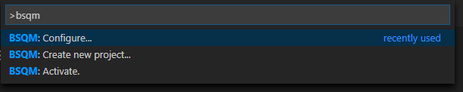

Ctrl+Shift+P

*bsqm.configure*

Enter

You might see this message…

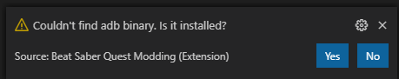

If you know where it is, click yes to choose the directory. If not, click no to download.

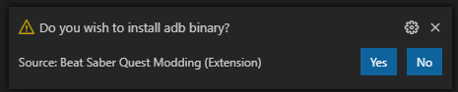

Same again with the NDK build script, and Git.

1. **Create a BSQM project**

Ctrl+Shift+P

*bsqm.create*

Enter

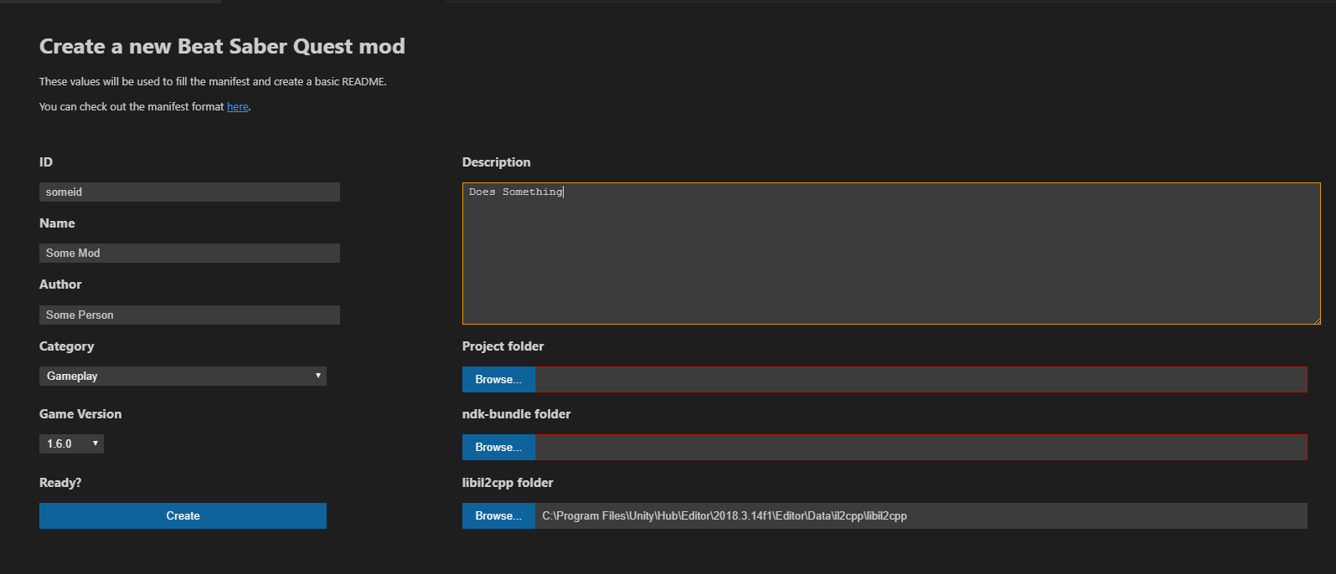

Fill out the

* ID: Something to identify the mod
* Name: The mod’s name
* Author: your name or username
* Category: Gameplay for this tutorial
* Game version: IMPORTANT use that latest version. We will change it to your game version later
* Project folder: Directory to a folder where the files will be generated
* NDK folder: MAKE SURE IT IS FILLED OUT. If it isn’t, browse and select the directory.
* Il2cpp folder: IF YOU HAVE MOVED

Click Create.

1. **Get the APK**

Open Sidequest

Connect your Quest



Click the grid



Click the gear next to Beat Saber



Click Backup Apk File



You can click the number to see the progress



When you see this...



… then click the grid and gear again, and this time click Open Backups



Unzip the file with WinRar or something else

Copy the following into a new folder:

* */assets/bin/Data/Managed/global-metadata.dat*
* */lib/arm64-v8a/libil2cpp.so*

1. **Extract the DLLs**

Download il2cppdumper <https://github.com/Perfare/Il2CppDumper/releases>

Make sure it is the non-netcore version



Extract and run the il2cppdumper application



Open the two files from the apk in the FOLLOWING ORDER

1. libil2cpp.so
2. global-metadata.dat

Wait patiently until the program says “Press any key to exit”, then do so.

Your dlls will be in the DummyDLL folder.



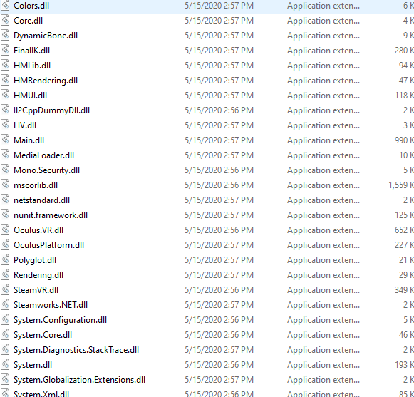

1. **Open the DLLs**

Download dnSpy <https://github.com/0xd4d/dnSpy/releases>

I recommend one of these, as it doesn’t require NET core to be installed.



Open dnSpy (not dnSpy.console)

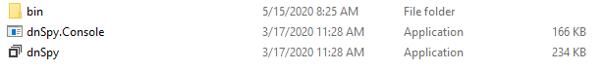

Drag Main.dll (located in DummyDLL) onto the left of dnSpy

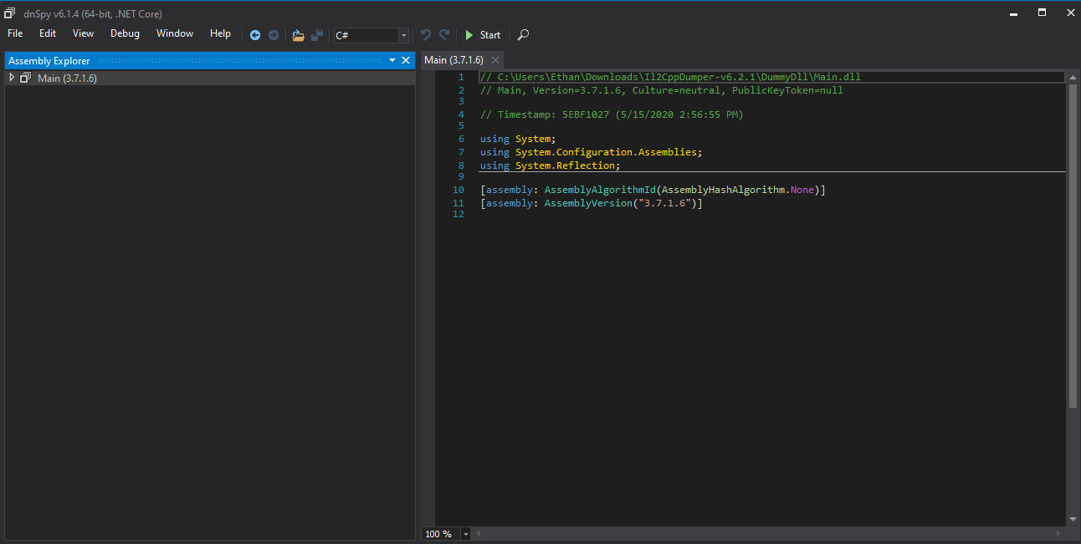

That’s it! All the Hook methods are in the tree!

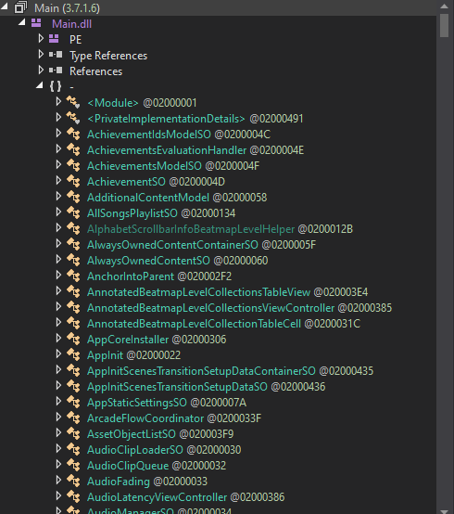

1. **Let’s Make a Note Miss Punishment!**

Now we will make an example mod this mod will spawn particle systems behind the player pointing forward, whenever they miss.

Open Visual Studio Code and navigate to  *(your mod folder)/src/main.cpp*

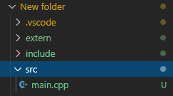

Replace the document with this:

*#include "../include/mod_interface.hpp"*

*#include <unordered_set>*

*#include "../extern/beatsaber-hook/shared/utils/utils.h"*

*#include "../extern/beatsaber-hook/shared/utils/logging.hpp"*

*#include "../extern/beatsaber-hook/include/modloader.hpp"*

*#include "../extern/beatsaber-hook/shared/utils/il2cpp-utils.hpp"*

*#include "../extern/beatsaber-hook/shared/utils/il2cpp-functions.hpp"*

*#include "../extern/beatsaber-hook/shared/utils/typedefs.h"*

*#include "../extern/beatsaber-hook/shared/config/config-utils.hpp"*

*static ModInfo modInfo;*

*static Configuration& getConfig() {*

*static Configuration config(modInfo);*

*return config;*

*}*

*static const Logger& getLogger() {*

*static const Logger logger(modInfo);*

*return logger;*

*}*

*extern "C" void setup(ModInfo& info) {*

*info.id = "tutorial";*

*info.version = "0.1.0";*

*modInfo = info;*

*getLogger().info("Modloader name: %s", Modloader::getInfo().name.c_str());*

*getConfig().Load();*

*getLogger().info("Completed setup!");*

*}*

*extern "C" void load() {*

*getLogger().debug("Hello from il2cpp_init!");*

*getLogger().debug("Installing hooks...");*

*il2cpp_functions::Init();*

*getLogger().debug("Installed all hooks!");*

*}*

*enum class Space {*

*World,*

*Self*

*};*

*DEFINE_IL2CPP_ARG_TYPE(Space, "UnityEngine", "Space");*

Now, this is the BASE of any mod. The *#includes* at the top basically tell the file where other code to run is. *extern "C" void load()* is a function that runs the code in it when the mod is loaded. *enum class Space* defines the world area.

Now, let's make particle systems appear on a note miss!

In dnSpy, there is a *NoteController* class. We are going to hook that.

First, we need to make a hook - to “hook” on to that function when it is called in the game. Under the  *#includes*, type  *MAKE_HOOK_OFFSETLESS(){}* to make a new hook. *MAKE_HOOK_OFFSETLESS* takes two or more parameters:

* The name of our hook
* Function return type
* Any parameters

In this example, we will hook *NoteController* on *SendNoteWasMissedEvent* , and we are going to need a name for this function. Let's call it *NoteCut*

As you can see in **dnSpy**, *SendNoteWasMissedEvent* is a *void*, so the second parameter is *void*.

The object will be *Il2CppObject* self*. So the third parameter will be that, too. That basically means this function - it*self*. *Il2CppObject\** is the return object of *il2cpp_utils*.

Altogether, the comma-separated parameters will be *NoteCut, void, Il2CppObject* self*, So put that in the parentheses:

*MAKE_HOOK_OFFSETLESS(NoteCut, void, Il2CppObject* self) {*

*}*

Because we made a hook, we have to install it. We will install it at the start of the game - in *extern "C" void load() { }*.

The function for installing a hook is *INSTALL_HOOK_OFFSETLESS()*. The first parameter is the same, *notecut*, because that is the name of our function.The other one is returned by *il2cpp_utils::FindMethodUnsafe*, the parameters of which are *NoteController*, *SendNoteWasMissedEvent*, and the number of extra parameters. There are none, if you look at *SendNoteWasMissedEvent* in **dnSpy**, there are no parameters in it. When there are parameters, you add there amount in the third parameter here, and themselves in the *MAKE_HOOK_OFFSETLESS* , with non c++ types as just *IL2CppObject\**:

*INSTALL_HOOK_OFFSETLESS(NoteCut, il2cpp_utils::FindMethodUnsafe("", "NoteController", "SendNoteWasMissedEvent", 0));*

Put it in *extern "C" void load() { }* to get

*extern "C" void load() {*

*getLogger().debug("Hello from il2cpp_init!");*

*getLogger().debug("Installing hooks...");*

*il2cpp_functions::Init();*

*INSTALL_HOOK_OFFSETLESS(NoteCut, il2cpp_utils::FindMethodUnsafe("", "NoteController", "SendNoteWasMissedEvent", 0));*

*getLogger().debug("Installed all hooks!");*

*}*

To finally spawn particle systems, make an empty GameObject. Put the following in the *MAKE_HOOK_OFFSETLESS* function.

*Il2CppObject* empt*y = CRASH_UNLESS(il2cpp_utils::New("UnityEngine", "GameObject"));

*CRASH_UNLESS* crashes the game if it can’t do what’s inside. It also helps convert optionals to *Il2CppObject\**. *il2cpp_utils::New* is the same as *new* in unity c#. To do c# *new GameObject*, you do the above. The parameters of il2cpp_utils::New are (most times) *UnityEngine* and the type. We have a GameObject type/

Next we need to add the particle system component:

*Il2CppObject* component = CRASH_UNLESS(il2cpp_utils::RunMethod(empty, "AddComponent", il2cpp_utils::GetSystemType("UnityEngine", "ParticleSystem")));*

To break that down. We get the type ParticleSystem from UnityEngine, and add that as a component to empty. The parameters of *RunMethod* are Class/reference, Function, and parameters of that function. The reference this time is *empty*, a variable we made for the gameobject. We *AddComponent* to it, and the parameter for *AddComponent* is the system type, which *GetSystemType* retrieves for us.

Setting a transform component is almost the same, but the component is there already, so we don’t add we set:

*Il2CppObject* transform = CRASH_UNLESS(il2cpp_utils::RunMethod(empty, "GetComponent", il2cpp_utils::GetSystemType("UnityEngine", "Transform")));*

All we changed is the variable name, the Add to Get, and the component itself.

Now that we have the transform reference, we need to set the position to behind the player:

*CRASH_UNLESS(il2cpp_utils::SetPropertyValue(transform, "position", Vector3{0,0,-5}));*

*CRASH_UNLESS* is a good debugging tool. It crashes your game when its function doesn’t work, so you can see what part broke. *SetPropertyValue* sets values in properties of components. We need a Class/reference (*transform*,our variable, not to be confused with *Transform* from unity), the variable that we’re the value of (*position*), and the value we set it to (*Vector3{0,0,-5}*). C# is different than C++, so we use *{ }* not *( )* in *Vector3*.

Finally, we need to let the game run the original functions of the hook we changed. Call the function:

*NoteCut(self);*

There should be a new particle system spawned each miss now.

*MAKE_HOOK_OFFSETLESS* should look like:

*MAKE_HOOK_OFFSETLESS(NoteCut, void, Il2CppObject* self) {*

*getLogger().debug("Level Started!");*

*Il2CppObject* empty = CRASH_UNLESS(il2cpp_utils::New("UnityEngine", "GameObject"));*

*Il2CppObject* component = CRASH_UNLESS(il2cpp_utils::RunMethod(empty, "AddComponent", il2cpp_utils::GetSystemType("UnityEngine", "ParticleSystem")));*

*Il2CppObject* transform = CRASH_UNLESS(il2cpp_utils::RunMethod(empty, "GetComponent", il2cpp_utils::GetSystemType("UnityEngine", "Transform")));*

*CRASH_UNLESS(il2cpp_utils::SetPropertyValue(transform, "position", Vector3{0,0,-5}));*

*NoteCut(self);*

*}*

Your entire main.cpp file should be:

#include "../include/mod_interface.hpp"

#include <unordered_set>

#include "../extern/beatsaber-hook/shared/utils/utils.h"

#include "../extern/beatsaber-hook/shared/utils/logging.hpp"

#include "../extern/beatsaber-hook/include/modloader.hpp"

#include "../extern/beatsaber-hook/shared/utils/il2cpp-utils.hpp"

#include "../extern/beatsaber-hook/shared/utils/il2cpp-functions.hpp"

#include "../extern/beatsaber-hook/shared/utils/typedefs.h"

#include "../extern/beatsaber-hook/shared/config/config-utils.hpp"

static ModInfo modInfo;

static Configuration& getConfig() {

static Configuration config(modInfo);

return config;

}

static const Logger& getLogger() {

static const Logger logger(modInfo);

return logger;

}

MAKE_HOOK_OFFSETLESS(NoteCut, void, Il2CppObject* self) {

getLogger().debug("Level Started!");

Il2CppObject* empty = CRASH_UNLESS(il2cpp_utils::New("UnityEngine", "GameObject"));

Il2CppObject* component = CRASH_UNLESS(il2cpp_utils::RunMethod(empty, "AddComponent", il2cpp_utils::GetSystemType("UnityEngine", "ParticleSystem")));

Il2CppObject* transform = CRASH_UNLESS(il2cpp_utils::RunMethod(empty, "GetComponent", il2cpp_utils::GetSystemType("UnityEngine", "Transform")));

CRASH_UNLESS(il2cpp_utils::SetPropertyValue(transform, "position", Vector3{0,0,-5}));

NoteCut(self);

}

extern "C" void setup(ModInfo& info) {

info.id = "tutorial";

info.version = "0.1.0";

modInfo = info;

getLogger().info("Modloader name: %s", Modloader::getInfo().name.c_str());

getConfig().Load();

getLogger().info("Completed setup!");

}

extern "C" void load() {

getLogger().debug("Hello from il2cpp_init!");

getLogger().debug("Installing hooks...");

il2cpp_functions::Init();

INSTALL_HOOK_OFFSETLESS(NoteCut, il2cpp_utils::FindMethodUnsafe("", "NoteController", "SendNoteWasMissedEvent", 0));

getLogger().debug("Installed all hooks!");

}

enum class Space {

World,

Self

};

DEFINE_IL2CPP_ARG_TYPE(Space, "UnityEngine", "Space");

Your code is ready! Make sure to save it

1. **Change game version**

In *bmbfmod.json*, there is a line:

"gameVersion": "1.6.0",

Change it to

"gameVersion": "1.10.0",

Or your latest Beat Saber version, and save.

1. **A few more things**

In *Android.mk* at Line ~43, change

-I'c:/Users/Ethan/Desktop/Unity/2018.4.15f1/Editor/Data/il2cpp/libil2cpp'

to

-I'c:/Users/Ethan/Desktop/Unity/2018.4.15f1/Editor/Data/il2cpp/libil2cpp' -frtti

Make sure in *main.cpp*, in extern "C" void setup, your mod id and version are correct.

Remember mod id? 

1. **Build**

Open buildbmbf.ps1

Click play in the top right

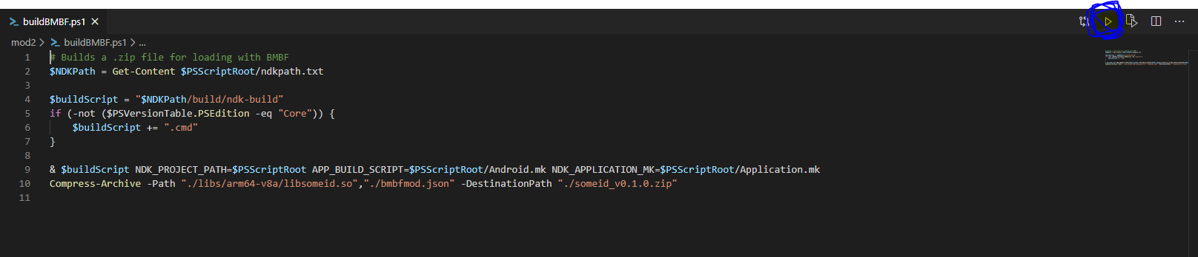

Open File Explorer and open your mod folder. If there is a zip file, you are good to go! Upload that to BMBF.

1. **Test**

Play a song! The game will punish you if you mess up!